:: Please keep this letter handy until the work is complete ::
Severn Trent Water
Customer Care
PO Box 407
Darlington
DL1 9WD

July 2024
Severn Trent Customer

Dear Customer

We’re improving your waste network
You may be aware, we’ve been upgrading the sewage pipes in your area as part of a £20million scheme to improve the waste network and overall river quality. A lot of this work has taken place in private land, however we sometimes need to work in the road.
Important information
- We will be closing a section of the A453 near Tonge in between Walton Hill and Moor Lane, which is used as access for the A42, for a period of 6 weeks from 15 August 2024 (shown on the map overleaf in red).
- The team will be working 7 days a week in order to complete the job and reopen the road as quickly as possible.
- Their working hours will be between 07:00AM and 18:00PM.
- For safety reasons no vehicles will be permitted access through the closure for the duration of the works.
- There will be a signed diversion route in place.

Retail businesses
If you own or operate a business which receives visiting customers who purchase goods or services from you and our works are affecting your sales income then please contact our Business Loss Team - businessloss@severntrent.co.uk for further advice.

Stay up-to-date with the work
- If you experience any issues with your water or sewerage service while the work is being done, please call our 24-hr operations centre on 0800 783 4444.
- Visit our website www.stwater.co.uk and look at our ‘planned improvements’ page for updates.
- Call me (Christina Massey) directly on 07974 119705 within normal office hours.
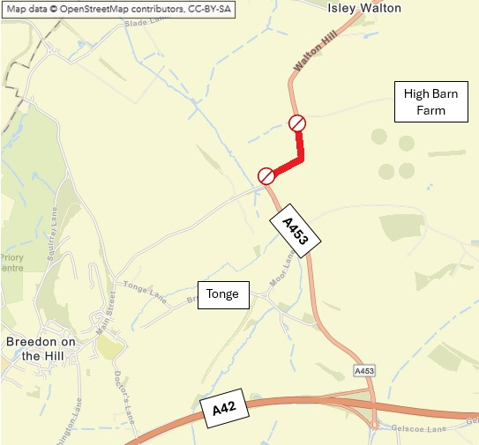
*Distances shown are approximate

Yours faithfully
Christina Massey
Communications Officer, Severn Trent

